Asian American Parent Alliance of San Diego  4653 Carmel Mountain Rd, # 308-220  San Diego, CA 92130  www.AAPASD.org Email: info@AAPASD.org | 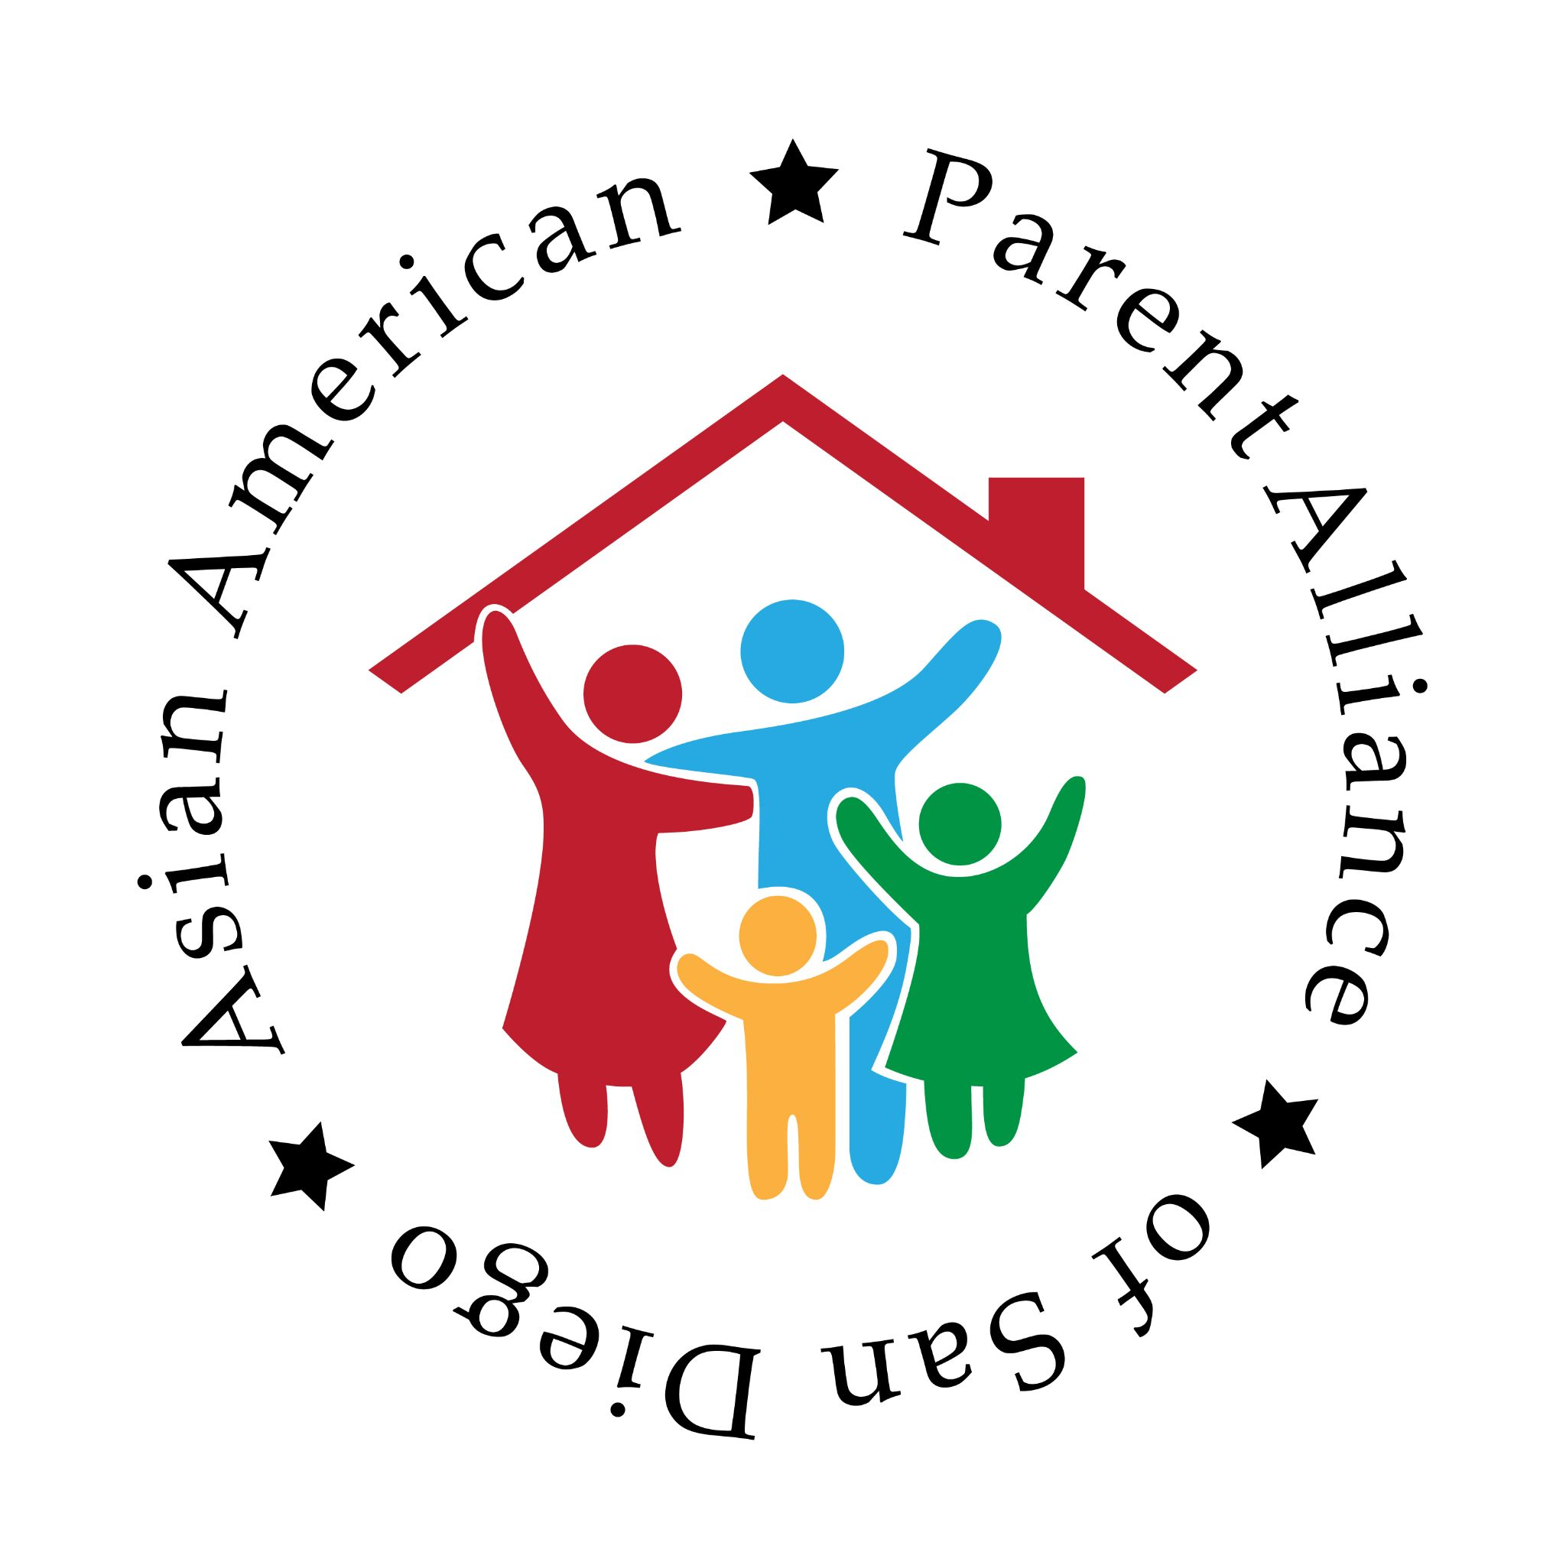
March 8, 2026
Dear Renee Combs,
On behalf of the Asian American Parent Alliance of San Diego (AAPASD), we would like to thank you very much for your support to AAPASD. Your care for the education of the youths will certainly have a great positive impact on their lives and on the future of our community.
Fostering Asian American community participation and providing a platform to advocate for merit-based education in San Diego County are the missions we are devoted to. Without your continuing support, we can never achieve these noble goals. Your support is the foundation of our organization.
If you have any questions about your donation or suggestion about how to improve this organization, please contact us based on the information provided above. If you wish to work with us as a volunteer, also kindly let us know.
Thank you again for your confidence and generosity!
Sincerely,
Team AAPASD
Accounting@AAPASD.org
Contribution Date | Amount | Sponsor | Payment Type
5/19/25 | [Amount] | Renee Combs | Zelle Payment
Asian American Parent Alliance of San Diego (AAPASD) is a nonprofit 501(c)(3) organization.
Tax ID: 88-2564739. Please retain this letter as receipt of your payment.

